|  |  |  |
| --- | --- | --- |
|  |  |  |

**Project: MARVERICK -DRESS**

**DESIGN & USER GUIDE DOCUMENT**



Created by: Nguyễn Tú & Lý Hoàng Sơn

Instructor: Trần Văn Hùng

Class: ACCP2302

**Date: 12-May-2023 to 12-June-2023**

|  |  |  |
| --- | --- | --- |
| This is to certify that:  Mr. Nguyễn Tú & Mr. Lý Hoàng Sơn  Has successfully designed, developed and hosted  **MAVERICK – DRESS**  Submitted by: Mr. Trần Văn Hùng |  |  |



**THANK YOU**

First of all, we would like to thank Aptech team for allow me to study throughout a sample project to work on real life projects, which I can improve myself and gained experience on how to analyze and design a basic project, skills to work without simply reading in books.

We also would like to thanks express our deepest thanks to Mr. HUNG for teaching and guiding the necessary professional knowledge so that we can best apply what we have learned during the process of making furniture. Mr. HUNG also is the one, who supports ưe in the process of making the project, helping me to offer practical and effective solutions during the implementation process.

Thank you to the administrators at the school who have supported me all the way over the past month.

During the implementation and reporting process, due to the lack of practical experience, errors cannot be avoided. I look forward to receiving your comments to help us in this area to be better. It is a valuable tool to help me improve my knowledge in the future. Help me fulfill my dream to continue on the path I am on.

Thank you very much and best regards!

**Table of Contents**

Content Page

Thank you 01

Table of contents 02

**Chapter 1: Introduction…………………………………………………………… 03**

1 Topic introduction………………………………………………………………………………………. 03

2 Research purpose………………………………………………………………………………………. 04

3 Meaning of the study………………………………………………………………………………….. 04

4 Concept of technology used……………………………………………………………………….. 04

4.1 Backend………………………………………………………………………………………. 04

4.2 Fontend………………………………………………………………………………………. 05

**Chapter 2: Analysis and design**………………………………………………………………… 07

1 Objects using the system……………………………………………………………………………. 07

2 System Requirements…………………………………………………………………………………. 07

3 Request the look and feel of the site………………………………………………………… . 07

4 System actors…………………………………………………………………………………………….. 08

5 Usecase diagram…………………………………………………………………………………………. 09

5.1 Admin usecase chart…………………………………………………………………. 09

5.2 User usecase chart…………………………………………………………………….. 11

5.3 Registration usecase chart…………………………………………………………. 11

5.4 Login usecase chart…………………………………………………………………….. 13

**Chapter 3: System installation**………………………………………………………………….. 14

1 Environment Settings……………………………………………………………………………………… 14

2 Launch the project………………………………………………………………………………………….. 15

3 Website interface…………………………………………………………………………………………….. 17

**Chapter 4: Assignment Table**………………………………………………………………………… 23

**Chapter 1: INTRODUTION**

1. **Topic introduction** *(tạm thời sử dụng lại)*

In the current era of 4.0 technology boom, we have witnessed the rapid development of science and technology, led by the field of information and communication technology. That has made a profound change in the social life and awareness of people. The application of information technology in people's daily life and work is very urgent. The application of computerization combined with communication is considered to be one of the decisive factors in the activities of governments, organizations, companies, as well as schools, it plays an important role. very important, necessary and indispensable role.

In addition, the demand for using the Internet is increasing and the forms of online business are increasingly diverse and rich. So when building this website on the online system, it will make it easier for customers to pay or buy products without having to go to the place to buy and pay directly like before. instead the online form is very suitable for the present time.

Besides, the current demand for programmers is a problem that has never decreased. Because now companies need developers with enough talent, ability to help their company grow, upgrade modern working environment, easy management through software, or product development. new, product maintenance.

In the past, when it comes to shopping, we have to go to the store to buy the product and people will immediately think of the scene of having to wait for time. Besides, manual product management makes customers spend a lot of time, now customers can view product information before choosing the right choice and immediately contact the store for advice. Specifically. Completely fast and effective.

When people's living standards are improved, the demand for home decoration of customers is increasing, helping customers to buy decorative lights according to their requirements and purposes easily and save time. At the same time, give customers information about new products, best-selling products or introduce incentives in the near future to customers.

1. **Research purpose**

Building a website helps the company produce online sales uniforms, as well as manage the company better, more conveniently and quickly. In addition, the system also helps people who want to buy products can order products at home without having to go to the store, choose their favorite products according to their personal preferences.

1. **Meaning of the study**

Through building this website, I can apply the knowledge gained during my studies at school, self-study knowledge from external sources into real work. Since then, I have gradually accumulated for myself valuable experiences during the project, which will later be the foundation to greatly support my work.

In addition, if the website is further improved, increased user experience, and put into practice, I believe that the resulting product will be of great help to store managers and shoppers.

Help customers need to buy online and pay quickly. Save a lot of time and money for people who want to buy goods without having to go to the store to buy. At the same time, it helps stores solve the problem of overcrowding in the current epidemic situation and it improves the problem of box office revenue after the epidemic.

Help improve the revenue of lamp shops as soon as the government allows people to participate in community activities after the epidemic: The business of the doors is open 24h/7. Anyone, anywhere, can access the website just with a phone or laptop connected to the Internet.

1. **Concept of technology used**

**3.1 HTML**

HTML stands for Hypertext Markup Language. It helps users create and structure elements in a web page or application, dividing paragraphs, headings, links, blockquotes, and more.

HTML is not a programming language, which means it cannot create “dynamic” functions. It's just like Microsoft Word, used to layout and format web pages.

**3.2 CSS**

CSS is a language for styling web pages – Cascading Style Sheet language. It is used to style and style elements written in a markup language, such as HTML. It can control the format of many web pages at the same time to save effort for web writers. It distinguishes the appearance of the web page from the main content of the page by controlling the layout, colors, and fonts.

**3.3 JavaScript**

JavaScript is a popular website programming language today, it is integrated and embedded in HTML to make the website more vivid. JavaScript acts as part of the web page, the executable allows client-side scripts from both the user side as well as the server side (Nodejs) to create dynamic web pages.

**3.4 Jquery**

Jquery is a fast, small, cross-platform and feature-rich JavaScript library. It is designed to simplify the client-side scripting of HTML. It makes things like HTML document traversal and manipulation, animation, event hading, and AJAX very simple with an easy-to-use API that works on a lot of diferent type of browsers

**3.5 Bootstrap**

Bootstrap is a free front-end for faster and easier web development.

Bootstrap includes HTML and CSS based design templates for typography, fomrs, buttons, tables, navigation, modals, image carosels and many other, as well as optional JavaScript plugins.

Bootstrap also gives you the ability to easily create responsive designs.

**3.6 Github**

Github is an Internet hosting service for software development and version control using Git. It provides the distributed version control of Git plus access control, bug tracking, software feature requests, task management, continuous integration, and wikis for every project.

**3.7 Mockapi**

MockAPI is probably the most minimal solution you will happen to run into. It is a tool that helps you quickly mock up APIs, generate custom data, and perform operations using a RESTful interface.

**Chapter 2: ANALYSIS AND DESIGN**

1. **Objects using the system**

There are 2 users of the system that I aim to be: Administrators (Admin), Customer:

* *Admin:* is an administrator member of the system, has the same rights and functions as product management, etc.
* *Customer*: has the functions of ordering and payment, viewing and searching for information about products, order function, etc

1. **System Requirements**

The portal will be designed as a Single-Page-Application and responsive Website with a set of pages and menus that represent choice of activities to be performed. The pages, menus, and other visual elements must be designed in a visually appealing manner with attractive fonts, colors, and animations. All of these should also be laid out in a responsive manner.

Looking at the demands and increasing power of web, the management of Maverick Dresses are looking for hosting a website of their products which will be easier to reach to them.

The Web site is to be created based on the following requirements:

1. The Top of the Page should contain logo of the site with suitable images.

2. Products should be categorized as

a. Shirts

b. Skirts

c. Frocks

d. P.T. T-shirts

e. P.T. shorts

f. P.T. track pants

g. Belts

h. Ties

i. Logos

j. Socks

3. There should be a “Contact Us” section which will have the Address of the Company which is as follows and the mail address which when clicked will invoke the local mail client from where they can send an email. Address of the Company should be displayed using GeoLocation API (eg. GoogleMaps).

4. Contact Us should have link for the address and contact details of various outlets of Maverick Dresses in the city.

5. Site map, Gallery, about us must be added.

6. Feedback must be allowed to enter in the website

7. Navigation must be smooth.

8. Color combination must be uniform throughout the project.

Over and above this, the portal should implement the following functionalities:

• Display a continuous scrolling ticker at the bottom of the page with current date, time, and location (hint: Use geolocation features of HTML5).

• Display a visitor count at the top right corner of the page beside a logo image.

• The menu options should change color on hover and also after clicking.

• Fade in and fade out options can be used for the menus.

1. **Request the look and feel of the site**

* *User Interface*
* The website has a good-looking interface, with a harmonious layout and coordination between colors and elements on the website.
* The functions are easy to use, convenient.
* Navigation must be smooth.
* *Management page interface*
* Simple interface, easy to manage.
* Display all management categories.
* Must be protected with the administrator's own account and password.

1. **System actors**

*Table 4.1 Actors in the system*

|  |  |  |
| --- | --- | --- |
| Num | Agent | The meaning and duties of Actor |
| 1 |  | The Admin agent is an agent that plays an important role in the system, who operates, manages and monitors all system activities.  The Admin agent can perform all the functions available in the admin system such as: Product management: add, edit, delete products |
| 2 |  | Users access the website, use the basic functions of the website such as login, view photos, view product information, view order information. |

*Table 4.2 System Functions*

|  |  |  |
| --- | --- | --- |
| Num | Function | Describe |
| 1 | Login | This function allows Admin, member users to access the system by account to perform their functions. |
| 2 | Product management |  |
| 3. | Seaching |  |
| 4. | Cart buying |  |
| 5. | Sort |  |
| 6. | Feedback |  |
| 7. | Location |  |
| 8. | Date and Times |  |

1. **Usecase diagram**

***5.1 Admin usecase chart***

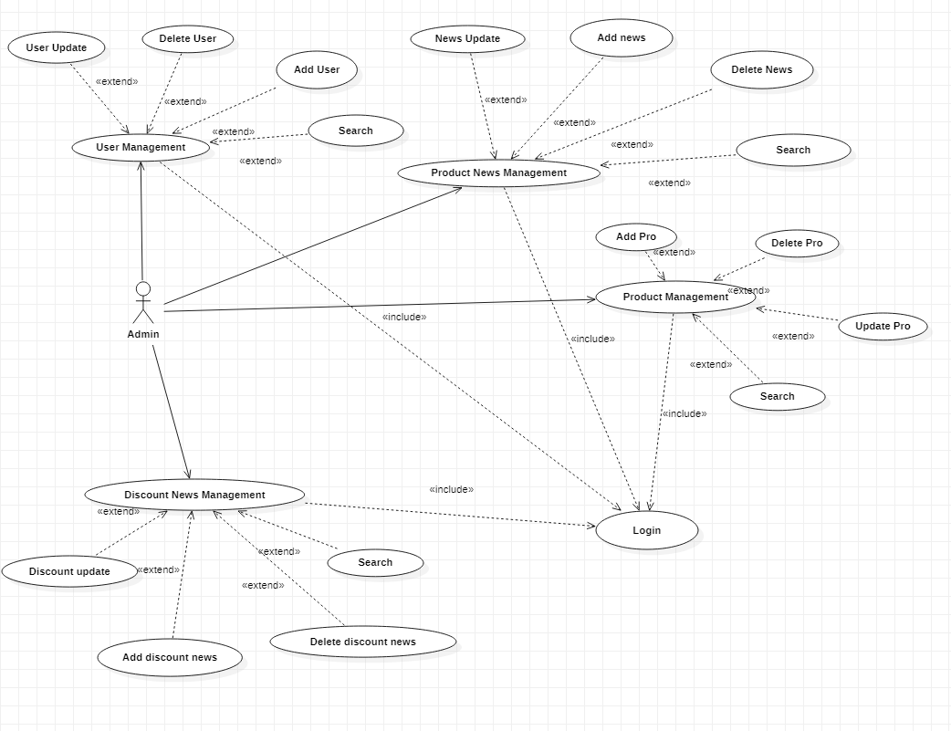

Figure 5.1 Admin usecase diagram

**Chapter 3: SYSTEM INSTALLATION**

1. **Environment Settings**

* *Install Visual Studio Code*

Download Visual Studio Code installation and install normally

­­­­­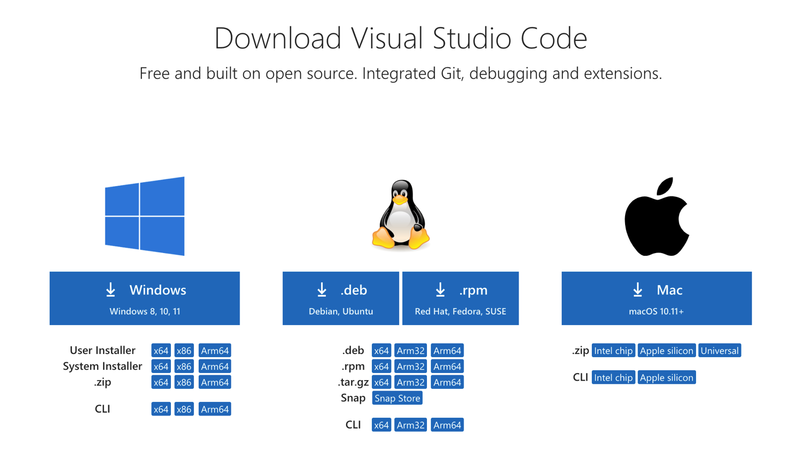

Figure 1.1 Download and install Visual Studio Code

* *Install Github*

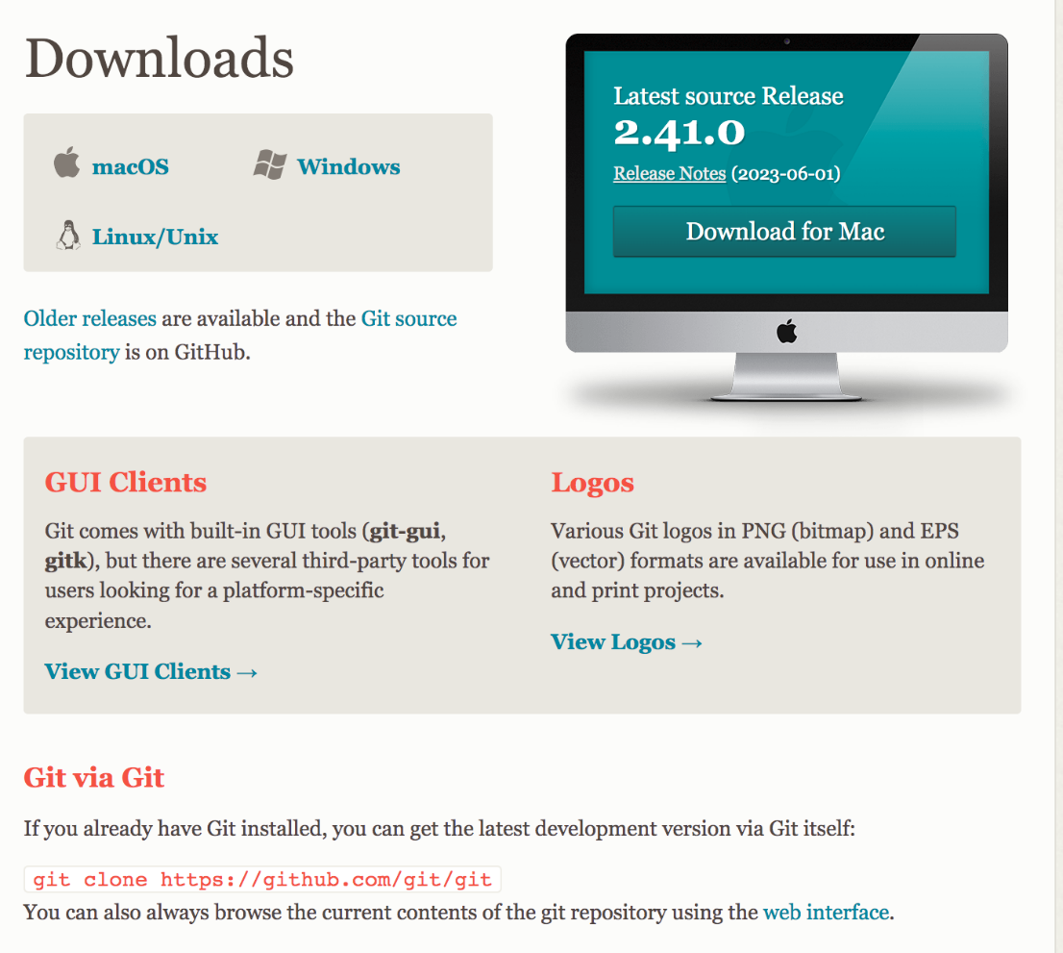

Figure 1.2 Download and install Github

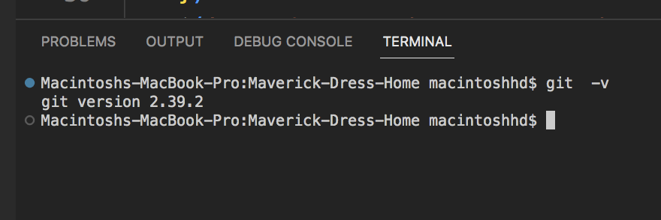

Figure 1.3 Check Github version if installed successfully

**2. Launch the project**

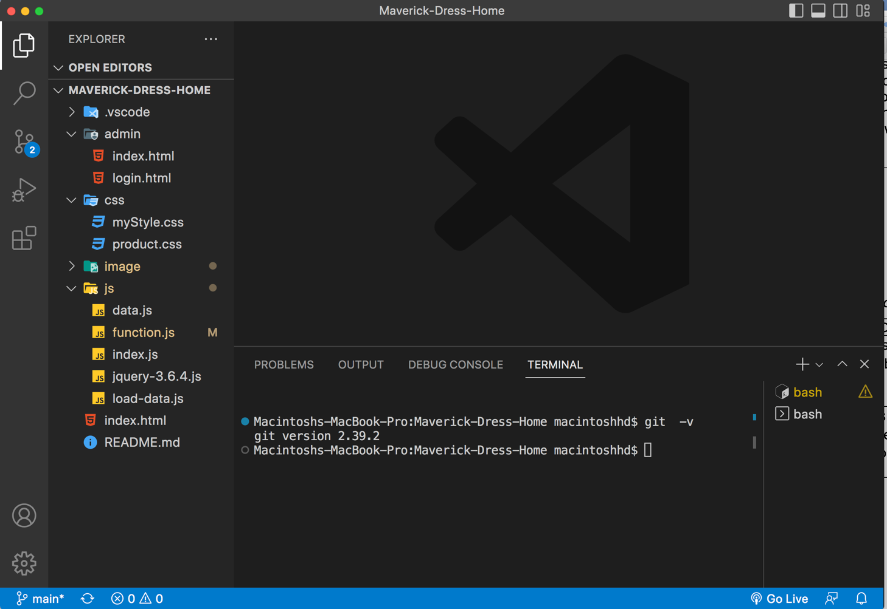

Figure 2.2 Launching the project to open the website

Figure 2.3 Interface after starting the project

**3. Website interface**

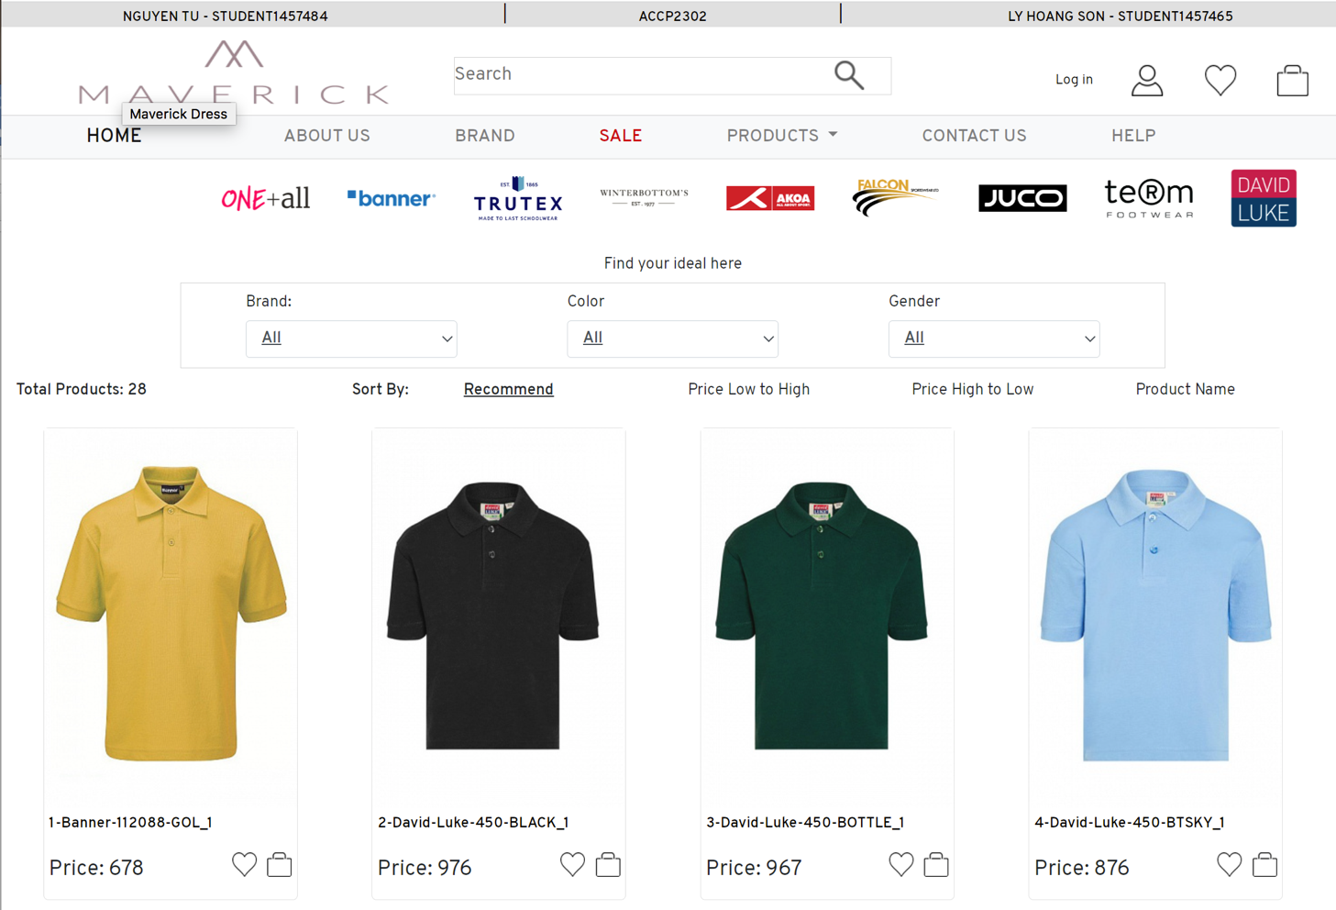

*3.1 Login page interface*

The login function uses a registered account to access the system. Only after logging in can you use the system's functions*.*

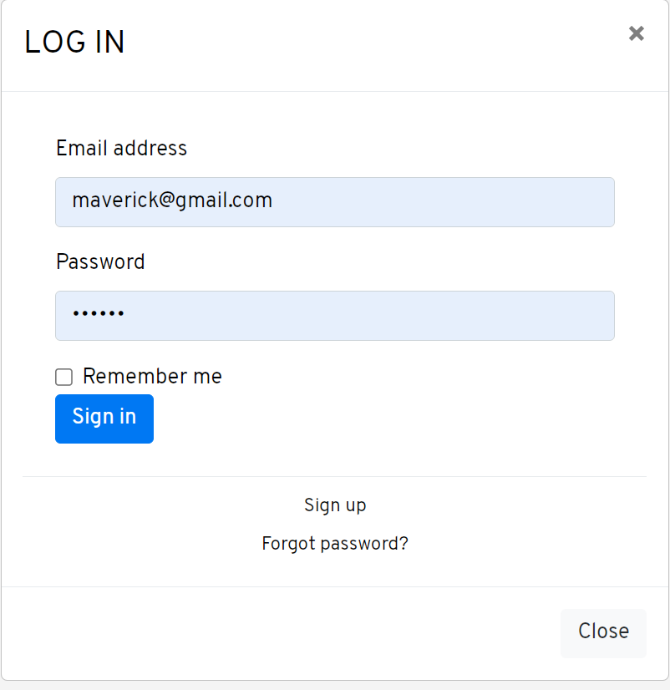

Figure 3.1 Login page interface

*3.2 Interface of the list of products being sold*.

The homepage interface displays an overview of the website. Here we can see the products being sold in stores, can view photos, place orders.



Figure 3.3 The interface of the product being sold

*3.4 Product menu by category, color, gender*

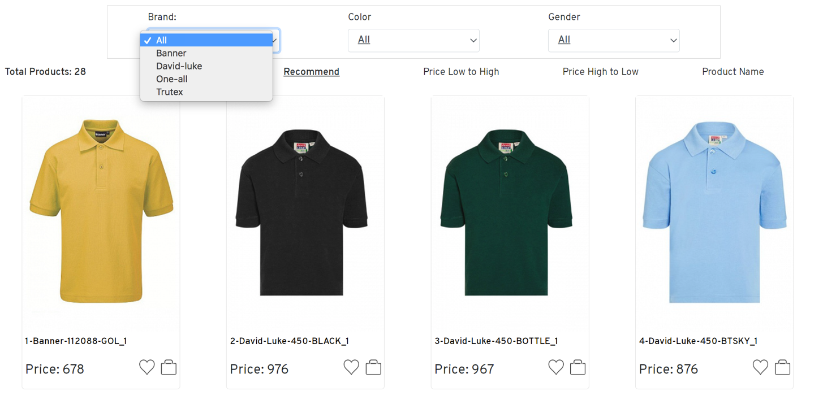

Figure 3.4 Product menu by category

*3.6 Interface view movie details*.

After choosing a favorite product, click on the light to make a purchase to view detailed information.

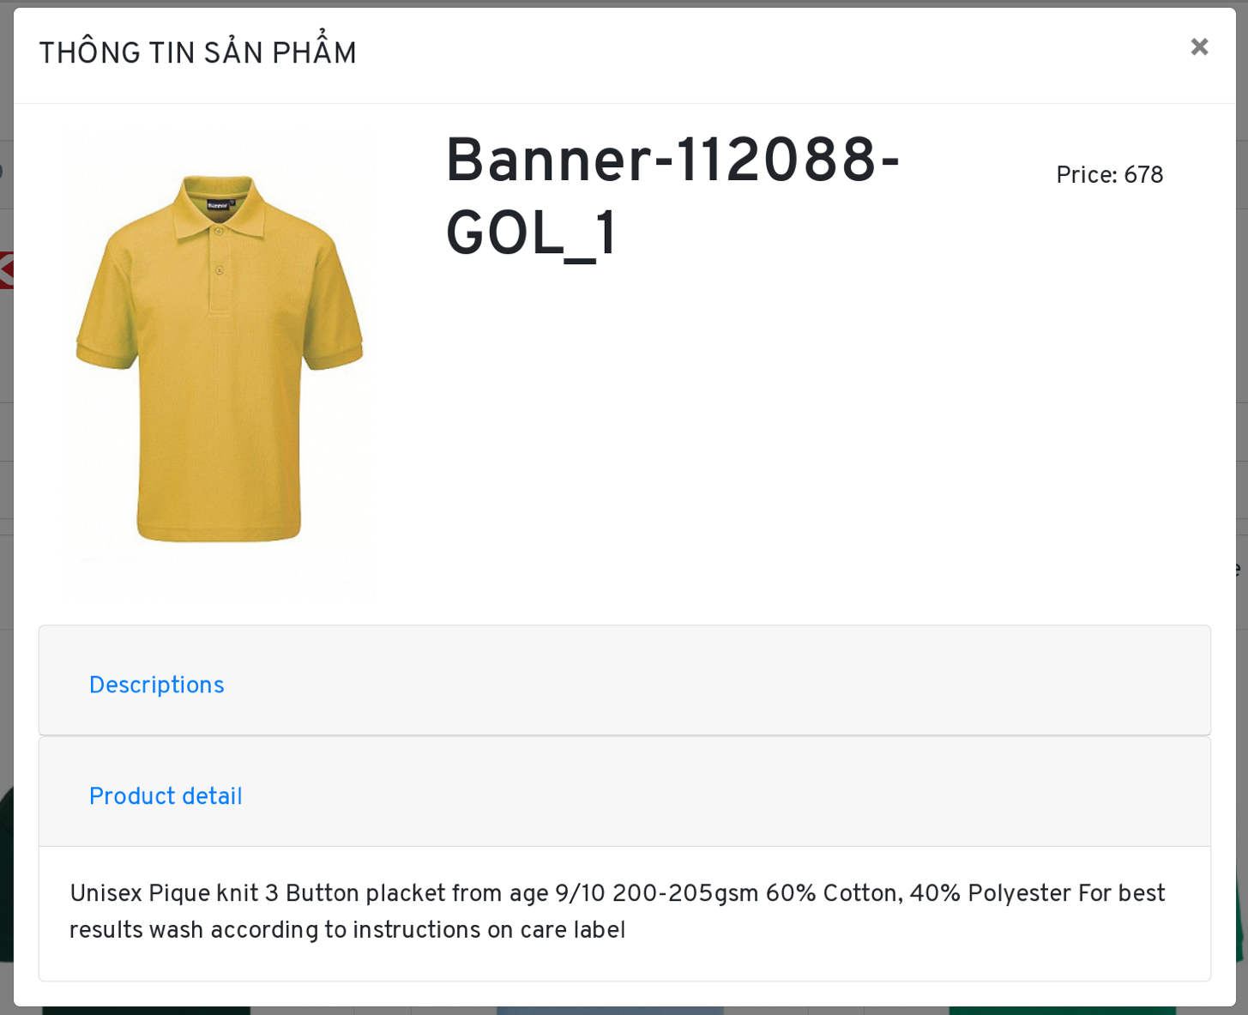

Figure 3.6 Interface view movie details

*3.7 Admin main page interface*

Admin main page interface

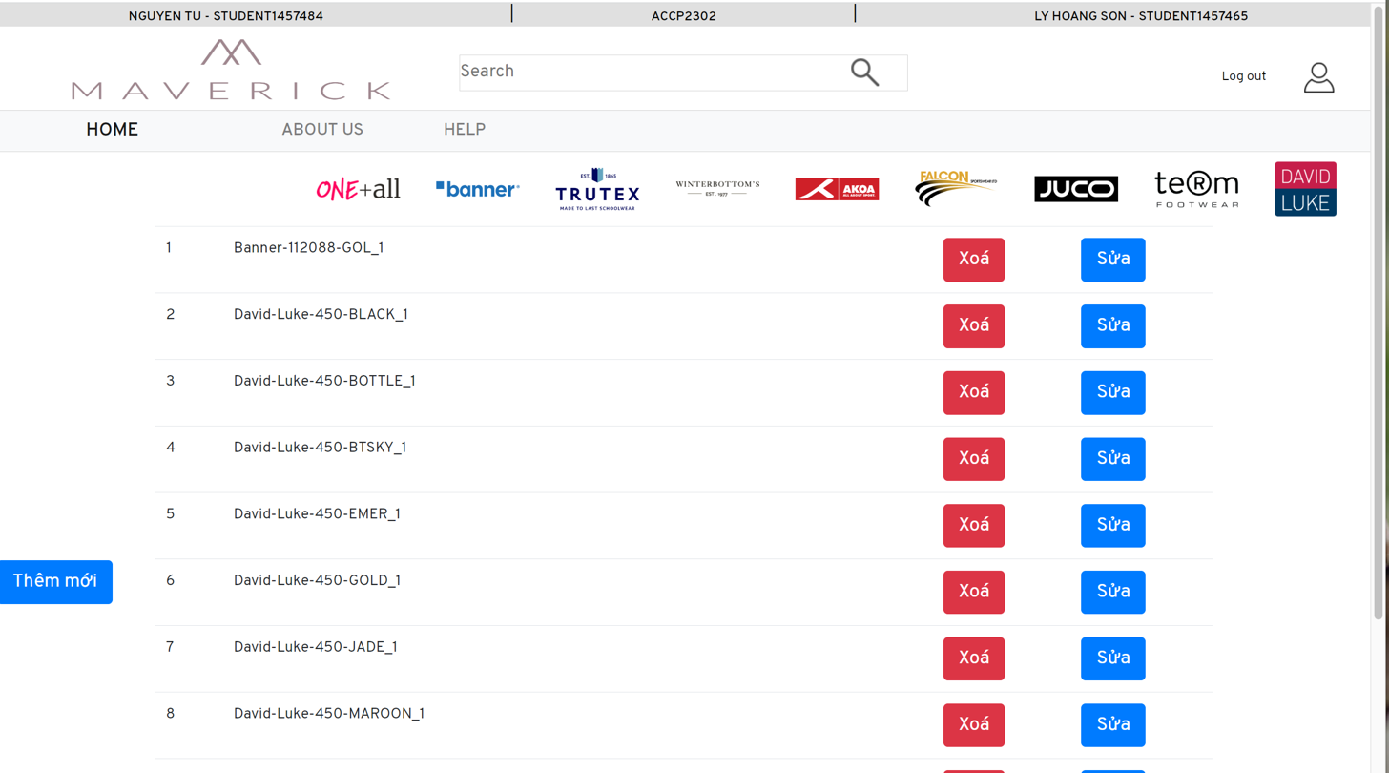

Figure 3.7 Admin main page interface

*3.8 Product management interface*

*3.8.1 Add product*

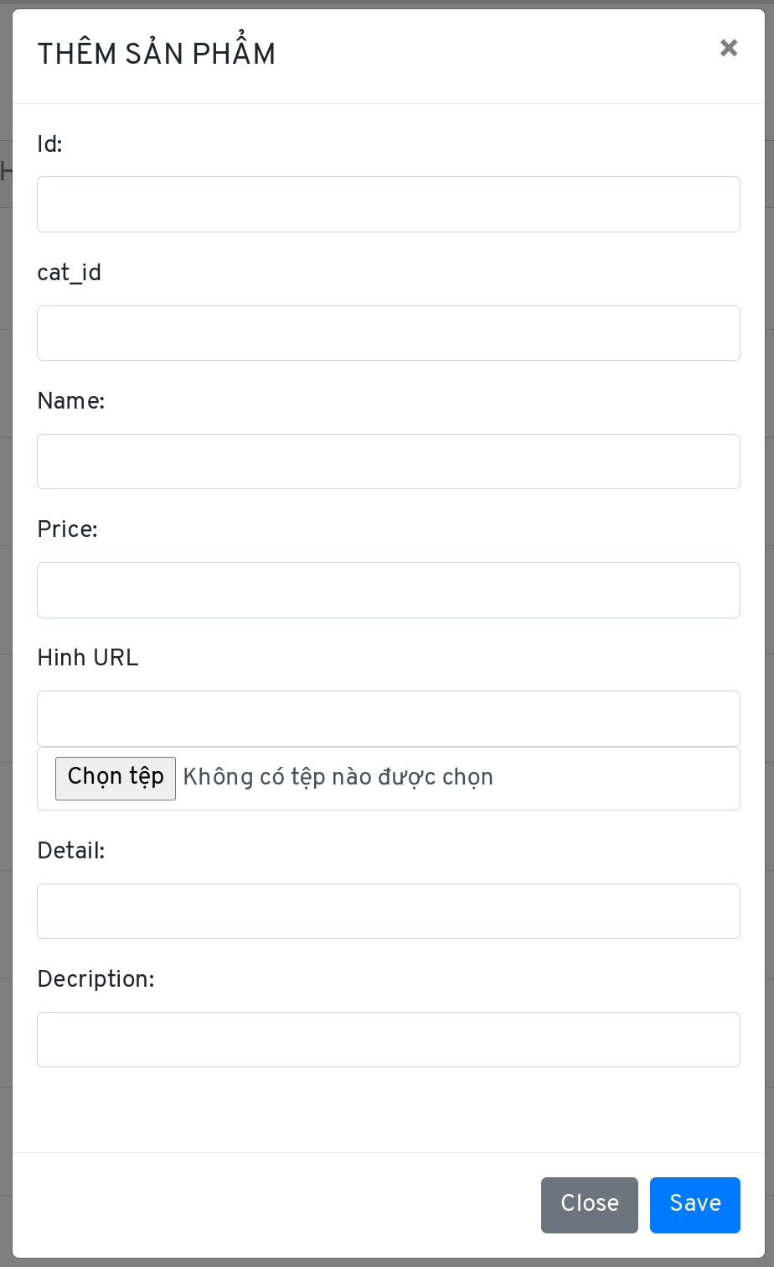

Figure 3.8.1 Add products interface

*3.8.2 Edit product*

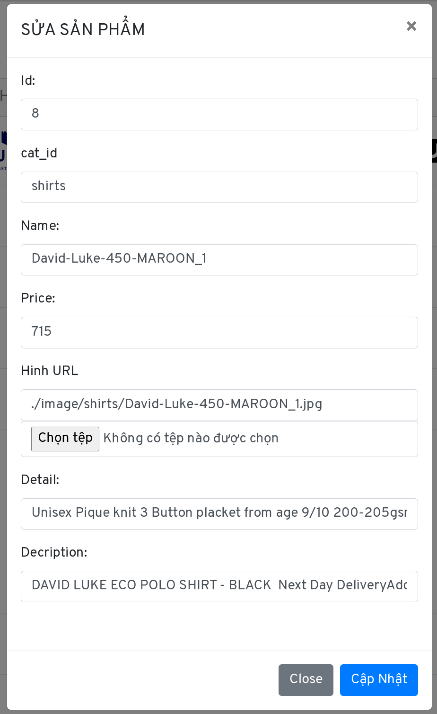

Figure 3.8.2 Edit products interface

*3.8.3 Delete product*

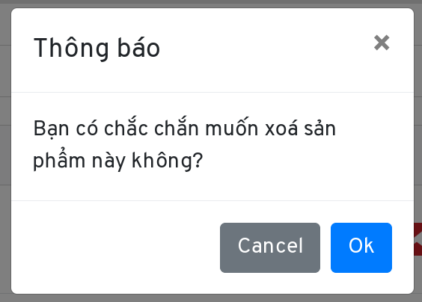

Figure 3.8.3 Delete products interface

**Chapter 4: Assignment Table**

|  |  |  |  |  |  |  |
| --- | --- | --- | --- | --- | --- | --- |
| **Job** | **Description** | **Expected**  **Start day** | **Actual start day** | **Finish day** | **Member** | **Status** |
| I. Planning website layout | Draft layout.  Learn Gibhub  Technology Selection (jquery, bootstrap).  Search for resources |  | 12/may/23 |  | Tu, Son | 100% |
| II. Design and code Homepage | Build layout (menu, header, main product, footer)  Write CSS for products.  Insert ifame |  | 17-may-23 |  | Tu, Son | 100% |
| III. Design and code product detail page | Dynamic data.  Responsive website.  Function search  Function soft  Page admin |  | 24-may-23 |  | Tu, Son | 100% |
| IV. Making connection | Complete main page layout.  Customine function: cart, details, products, |  | 31-may-23 |  | Tu, Son | 100% |
| V. Adding functions | Test the entire website.  Upload hostign |  | 07-jun-23 |  | Tu, Son | 100% |
| VI. Testing & Editing | Testing and fixing bugs |  |  |  | Tu, Son | 100% |
| VII. Startup | Summary |  |  |  | Tu, Son | 100% |

**REFERENCES**

**Web**

<https://www.w3schools.com/html/>

<https://stackoverflow.com/>

<https://react-bootstrap.netlify.app>